NIA 6 Updates

All of the previous NIA6 newsletters can be found in the news section on the Sixth Form website.

GCSE Resit Results and Timetables
GCSE resit results will be released on Thursday 8 January. Students should also check Arbor for any timetable updates.

INSET exams and revision
Applied Science
Three small exams make up the unit. Tuesday 6th AM and PM, Wednesday 7th PM. Revision session on the Monday PM (1-3pm, LAI/RCO room 156) and Tuesday PM (Bio - TAS room 149) after their PM exam.

Sport revision
There will be a Year 13 Sport revision session on Tuesday 6th January, running from 1:00pm to 3:00pm.
This session has been arranged to support students in preparing for their Unit 2 exam, which will take place on Wednesday 7th January. Attendance at the revision session is strongly encouraged, as it will provide focused guidance and an opportunity to reinforce key content ahead of the assessment.
The revision session will be held in room 133 on Tuesday 6th January.

Candy Canes of Kindness
Our NIA6 students took part in our Candy Canes of Kindness initiative, spreading festive cheer through thoughtful messages and acts of kindness across the academy. A big thank you to everyone who took part — it was wonderful to see such positivity and community spirit.
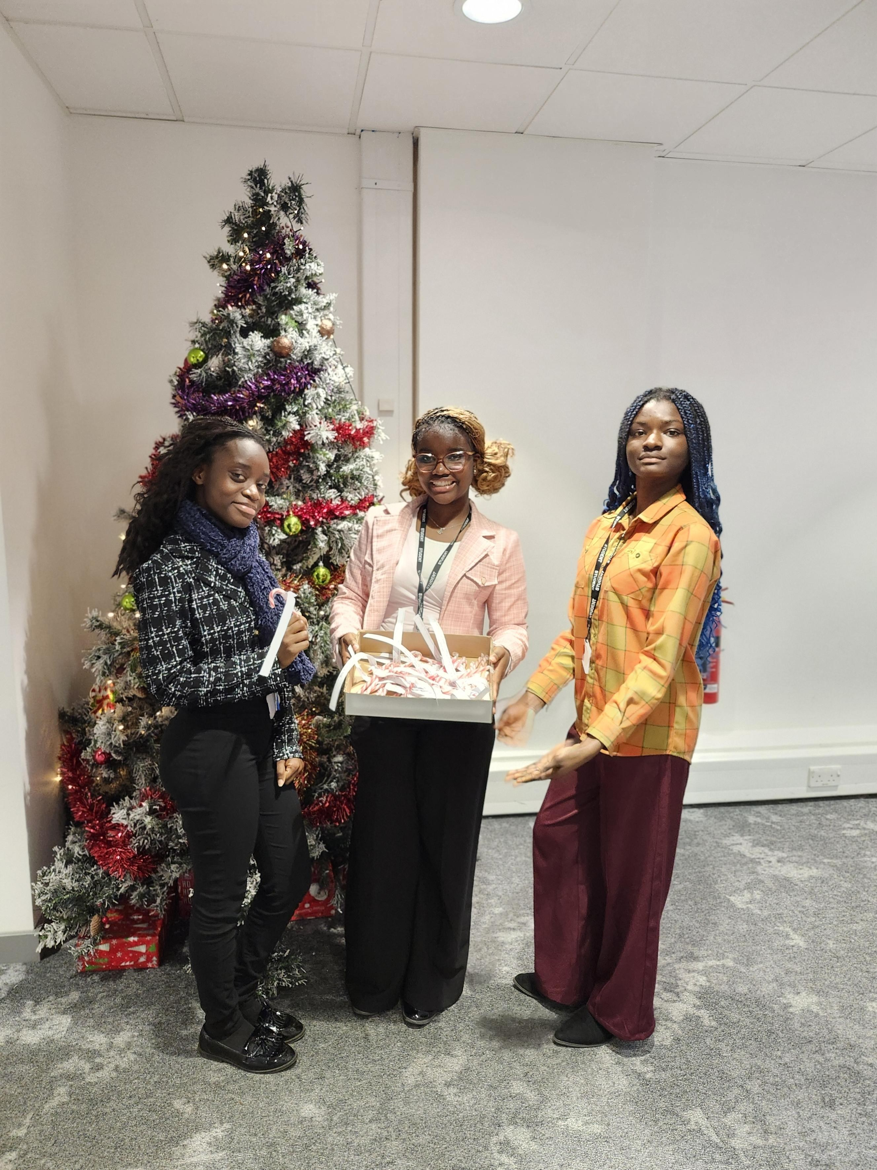
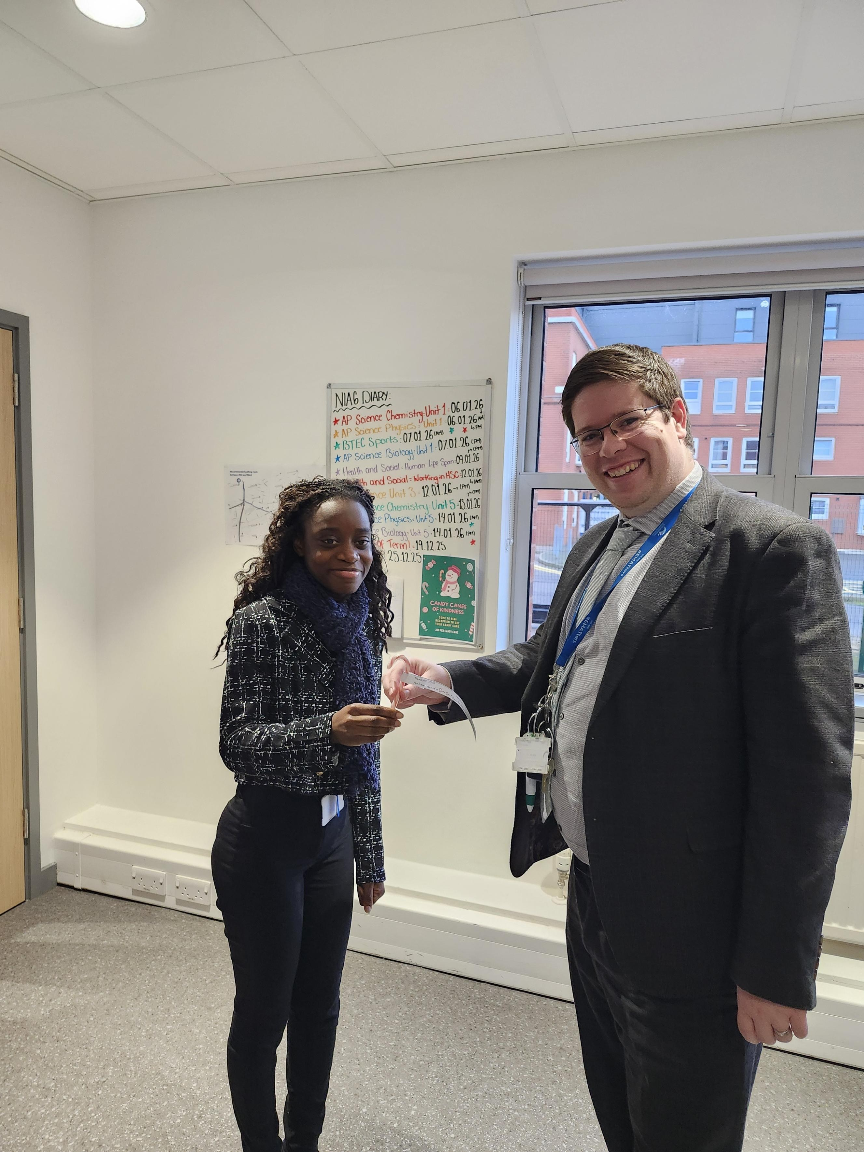
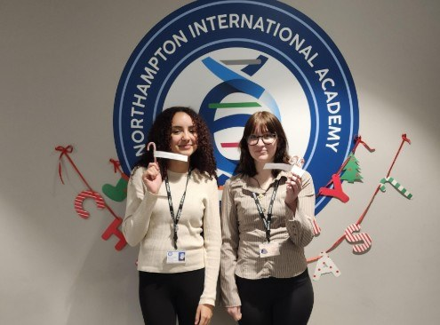

Thought for the week

Everyone has the potential to succeed academically, but ensuring that we are successful human beings by living well together is equally if not more important.

Year 13 Parents Evening – 15th January
A reminder for Year 13 students and families: Parents Evening will take place on Wednesday 15th January. Please make appointments with your subject teachers and your mentor.
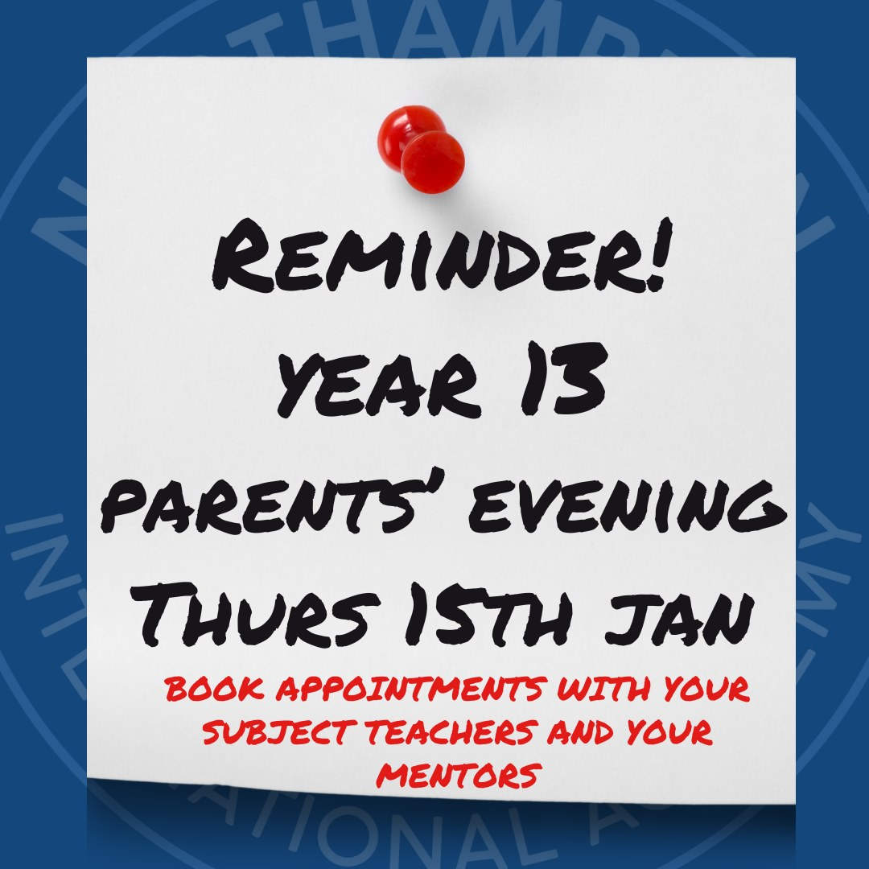

Look back at term 1
We've had a fantastic term at NIA6, well done to everyone for all of your hard work and achievements over the past few months.
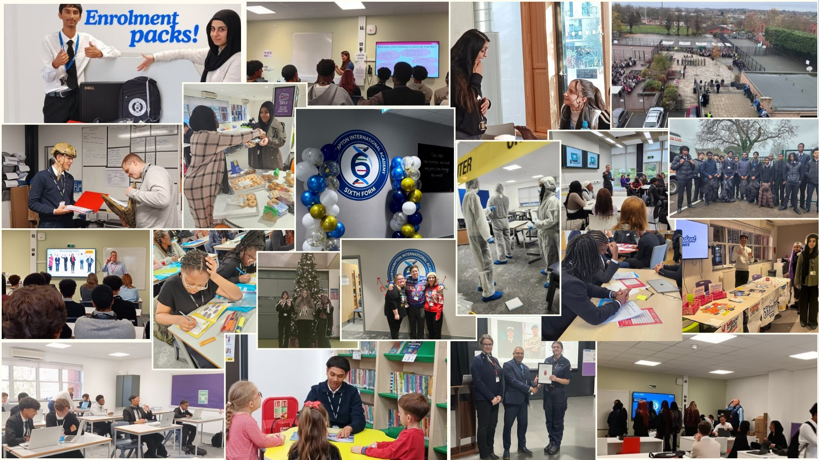

End of Term Awards Assembly
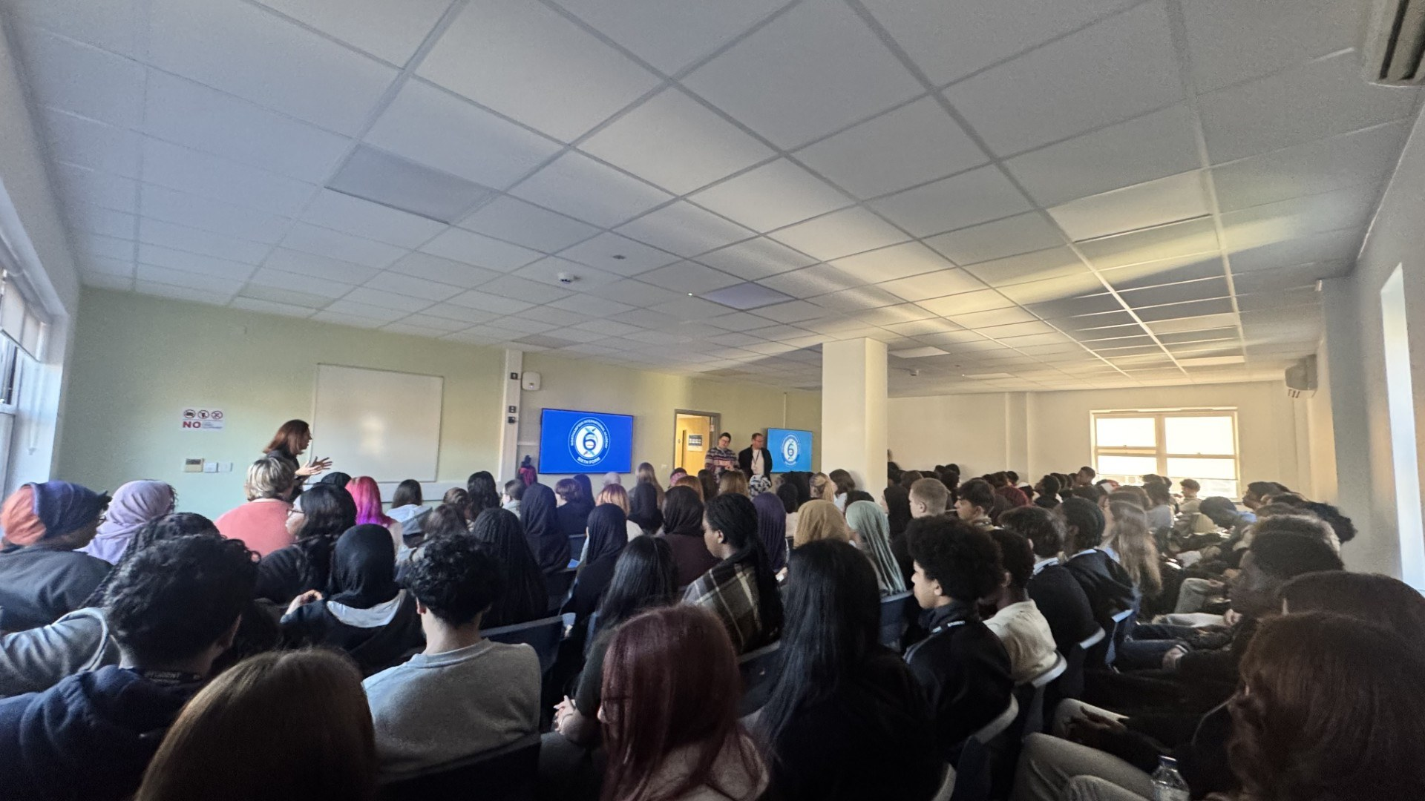
We ended the term by celebrating our students achievements at our End of Term Awards Assembly, recognising hard work, commitment, and success across the term.

Merry Christmas from the NIA6 team
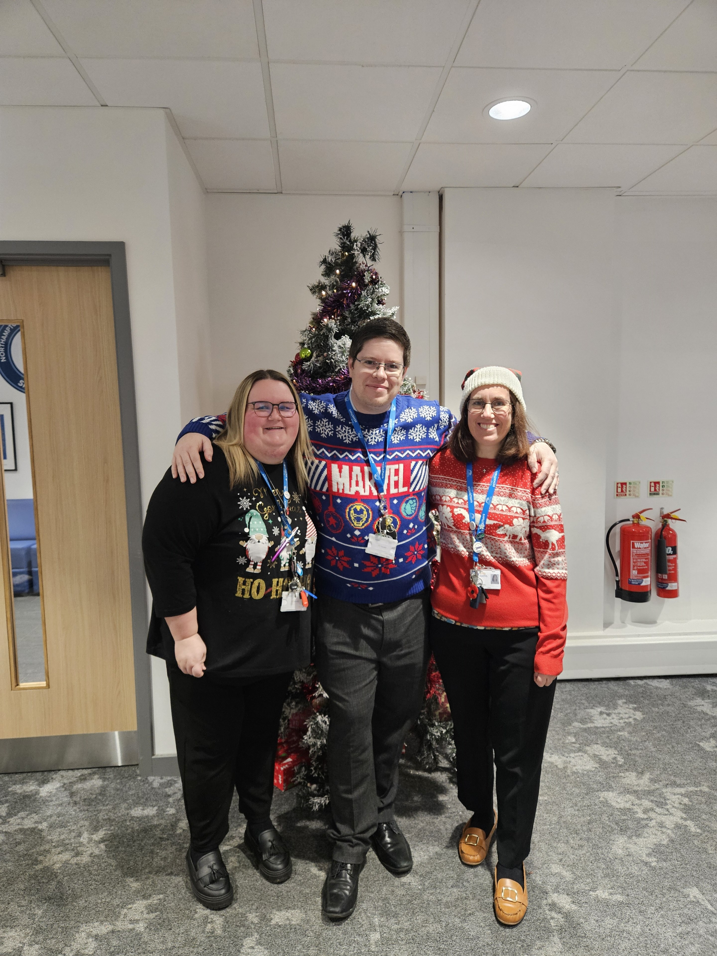

This week's attendance
