Year 12 History preparation – Tsarist and Communist Russia 1855- 1964
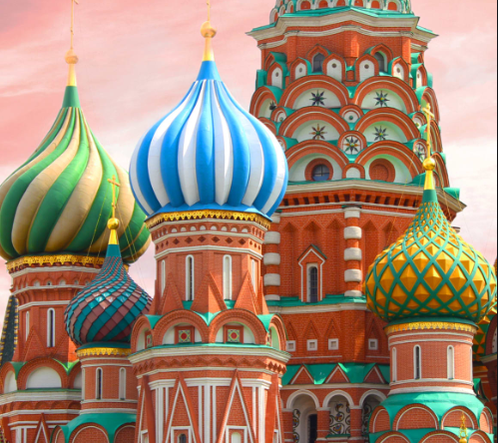
As your teacher for the AQA Tsarist module I will be expecting you to be organised and independent, from having your own folder and paper to spending time reading around our lesson learning.
To help you fully prepare not only to start the course but also to get used to an A-Level way of studying I have created some tasks below that you could aim to complete before starting in September. Each week is approximately an hours’ worth of work, with some tasks being longer because they include watching videos/series.
Week 1
- • Make a poster of all the tsars from 1855– 1914 with their family members and beliefs .
Week 2
- To understand the context preluding the start of our course, watch the Romanovs documentary on YouTube you need to start on episode 7 at 24 minutes 35 seconds Alexander II. I would recommend that you watch up to and including episode 9 and make a mind map of the main events.
Week 3
- Complete a factfile for the following key individuals, Piotr Stolypin, Sergei Witte, Gregori Rasputinand Georgy Lvov.
Week 4
- Design a poster on what life in Russia was like by 1855, you need to show what it was like for the different sections of society as well as explain how much freedom people had.

Suggested websites to help with tasks above;
https://www.youtube.com/watch?v=mYo8SEvnsrM
https://www.youtube.com/watch?v=ZZ55ZvBe07U
https://www.audiopi.co.uk/subjects/history/a-level/aqa/tsarist-and-communist-russia-1855-1964/ which are a set of podcasts.
https://www.bbc.co.uk/programmes/b0b2gspd (Radio programme about the Emancipation of the serfs) https://www.historylearningsite.co.uk/modern-world-history-1918-to-1980/russia-1900-to1939/russification/ (Detailed information about Russification)
https://alphahistory.com/russianrevolution/october-manifesto/ (A thorough summary of the October Manifesto)

AQA Making of Tsarist and Communist Russia Course Reading List
(You could purchase online and start reading or see book reviews on Google Books/Scholar)
Key texts for reading
- J Bromley, Russia 1848–1917, Heinemann, 2002
- G Darby, The Russian Revolution, Longman, 1998
- D Evans and J Jenkins, Years of Russia, the USSR and the Collapse of Soviet Communism, Hodder Arnold (2nd edn), 2001
- J Hite, Tsarist Russia 1801–1917, Causeway Press, 2004
- J Laver, The Modernisation of Russia 1856–1985, Heinemann, 2002
- S J Lee, Russia and the USSR, Routledge, 2005
- M Lynch, Reaction and Revolutions: Russia 1881–1924, Hodder Murray (2nd new edn), 2005
- D Murphy and T Morris, Russia 1855–1964, Collins, 2008 • A Wood, The Russian Revolution, Longman (2nd edn), 1986
Biographies and first-hand accounts
- I Deutscher, Stalin, Penguin, 1970
- D Lieven, Nicholas II Emperor of all the Russias, Pimlico, 1994
- S S Montefiore, Stalin, The Court of the Red Tsar, Phoenix, 2003
- V Serge, Memoirs of a Revolutionary, Writers and readers publishing co-opertive, 1984
- R Service, Lenin: A Biography, Pan Books, 2002
- B Williams, Lenin (profiles in power), Longman, 2rd edn, 2000

Revision Guides
