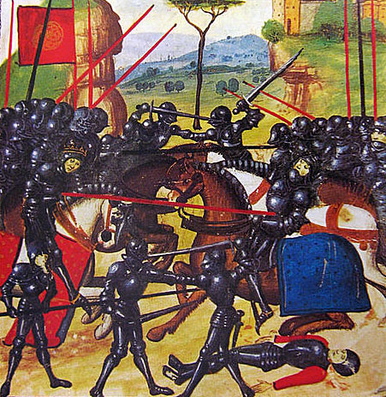
The Wars of the Roses
Welcome to Year 12 History at NIA! One of our units is on late medieval England, and covers the period from 1450 to 1499.
We don’t expect you to become an expert over the summer holiday, but it will help if you have an overview (a rough idea) of the Wars of the Roses and the main themes we will be covering.
Here are some ideas for you:

Dan Jones’s documentary series on the Wars of the Roses, England’s Bloody Crown:
This four part TV series is available on youtube:
https://www.youtube.com/watch?v=SB_OThWd-eA&t=979s
https://www.youtube.com/watch?v=fG1NpCE1B5k
https://www.youtube.com/watch?v=TeFRXB1LLYQ
https://www.youtube.com/watch?v=e3qER3Z3QyA
As you watch the series, look out for the following information:
- Who were the main kings in this period, and were some more successful than others?
- Which were the two rival dynasties (royal families) who were competing for power during the Wars of the Roses?
- Were there any queens who played significant roles in the events of this period?
- Why was the Earl of Warwick known as “The Kingmaker”?

Richard III research task:
Use the internet to research the following question: “why is Richard III such a controversial king?”
Here are two youtube documentaries to help you:
- Documentary looking at the new evidence from Richard’s skeleton, particularly his spinal deformity: https://www.youtube.com/watch?v=4eDtsnQnFfQ&t=1s
- Tony Robinson on the “mystery” of the Princes in the Tower: https://www.youtube.com/watch?v=bkRftHETKjU

