Graphic Modelling Task

- Think of your favourite game (as inspiration).
- Design and make a prototype travel board game, with counters and instructions.
- This game will use mainly card with Styrofoam pieces.
- It must be innovative, creative and appeal to children.
- Remember, games can be played many times and should not be based around the latest ‘fad’!

You will be assessed on:
- Concept (A3 page of ideas)
- 1 A3 page of final design
- Prototype (inc piece/s and instructions)
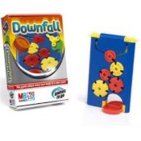
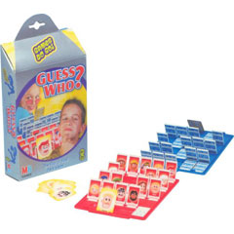
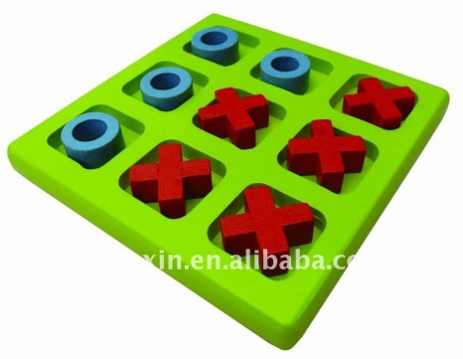
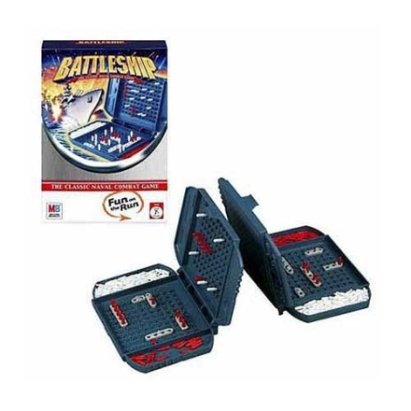
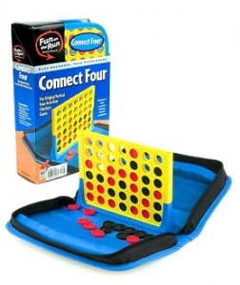

What do all these popular games have in common?
Simple, multiple outcomes, compact, timeless….
All these titles have sold millions over many years so it must work!
Try not to:
- Be too complex (although too simple could be boring?!)
- Have too many pieces
- Spend a lot of time on the finish (it is a prototype)

Good Luck…

