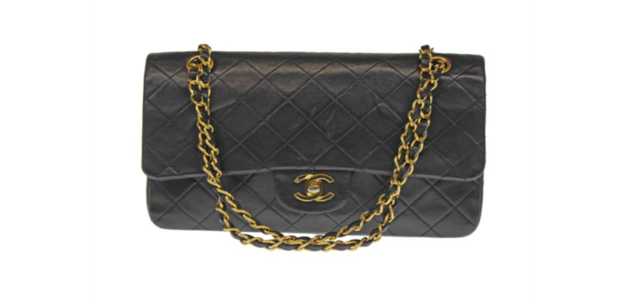
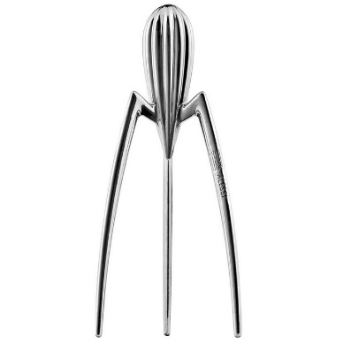
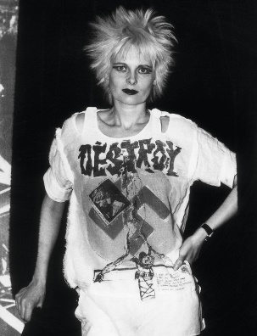
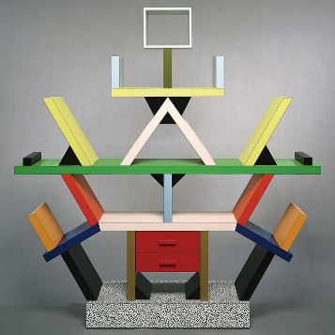
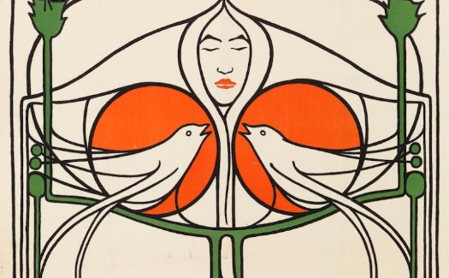
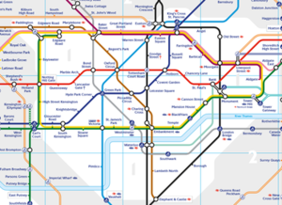
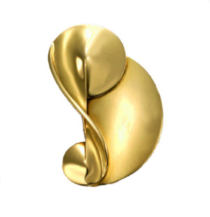
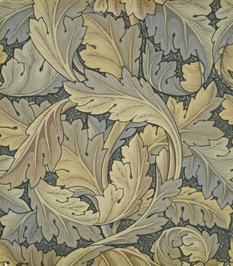
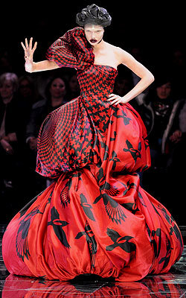
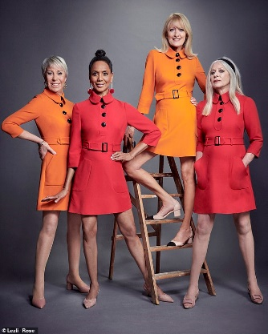
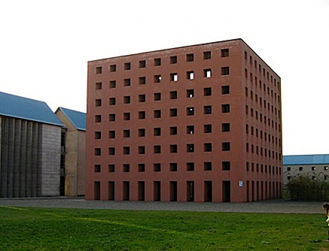
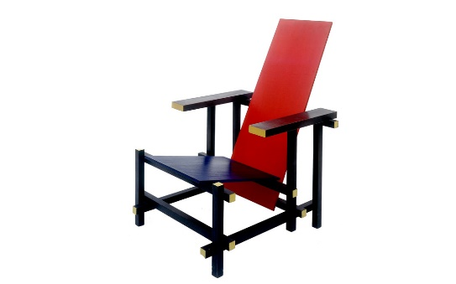
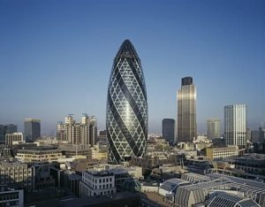
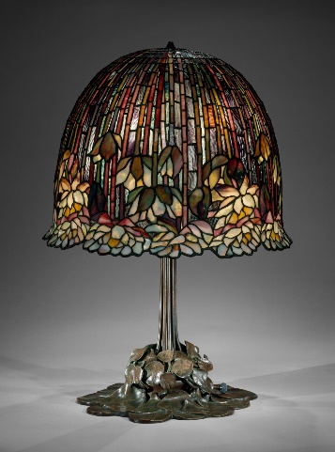
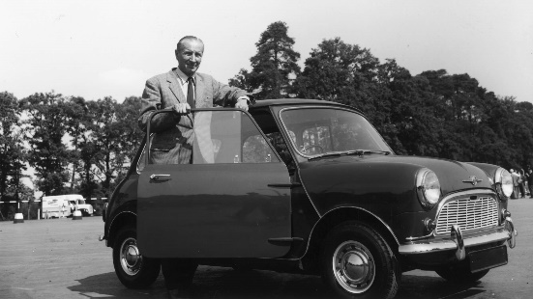
V
Name each designers work in given box.

TEST
Key Designers
Name:
- What is the current London Underground map based on?

- Who did Vivienne Westwood often work with (also the manager of Punk group, the Sex Pistols)?

- Which designer worked closely with design firm, Alessi?

- There is a house designed by this person in the Derngate, Northampton. Who is it?

- The ‘Bauhaus’ style of design is strongly linked to which designer?

- Who designed the still popular small car, the Mini?

- Amongst many things, floral design wallpaper is associated with who?

- Apart from Westwood, name the other 2 fashion designers from our key designers.

- In which country was Gerrit Reitvelt born?

- Which architect is known for using mostly steel and glass in his buildings?

Choose any designer and answer …
11) when they were born
12) where they were born
13) what they are mainly known for
14) give one example of their work (name a piece or describe it)…

