NIA Biology Department
Induction booklet for A Level Biology
September 2020

Name:
GCSE Grade for Biology (Double or Triple):
What other subjects have you chosen for A Level?

Any problems please email: matthew.manning@nia.emat.uk

This booklet will hopefully help bridge the gap between GCSE Biology and the A level. Please use it to support your studies over the next two years. This booklet is not optional and will be taken in to be marked by your teachers in September.

Welcome to A Level Biology!
Resources for A Level Biology that you should familiarise yourself with:
The specification
https://www.ocr.org.uk/qualifications/as-and-a-level/biology-a-h020-h420-from-2015/
Biology Handbooks (Practical, Maths and Drawing skills)
https://www.ocr.org.uk/qualifications/as-and-a-level/biology-a-h020-h420-from-2015/planning-and-teaching/

Resources you will be given in September
OCR Biology A Specification: http://www.ocr.org.uk/qualifications/as-a-level-gce/as-a-level-gce-biology-a-h020-h420-from-2015/
Textbook: A level Biology for OCR (Ann Fullick)
Lab Book

Resources that may be useful
Revision Guide: OCR A Year 1 & 2 Complete Revision and Practice (CGP)
Maths Revision Guide: Essential Maths Skills for A-Level Biology (CGP)
Practical Skills: Practical Biology A and B (Richard Fosbery)
Biological Sciences Review
Maths for Biologists: http://www.ocr.org.uk/qualifications/by-subject/biology-related/maths-for-biology/
https://www.khanacademy.org/science/biology

Home Learning tick list:
- Create an A4 sized poster to show what is found inside the cell and annotate your drawings with the functions of each organelle as listed on the specification (follow the link above). You will find space for this at the end of this booklet.
- Complete this work booklet and bring it to your lesson next week.

Guidelines for results tables
The following guidelines should be followed when presenting results in tables:
1 | All raw data in a single table with ruled lines and border.
2 | Independent variable (IV) in the first column; dependent variable (DV) in columns to the right (for quantitative observations) OR descriptive comments in columns to the right (for qualitative observations).
3 | Processed data (e.g. means, rates, standard deviations) in columns to the far right.
4 | No calculations in the table, only calculated values.
5 | Each column headed with informative description (for qualitative data) or physical quantity and correct units (for quantitative data); units separated from physical quantity using either brackets or a solidus (slash).
6 | No units in the body of the table, only in the column headings.
7 | Raw data recorded to a number of decimal places appropriate to the resolution of the measuring equipment.
8 | All raw data of the same type recorded to the same number of decimal places.
9 | Processed data recorded to up to one significant figure more than the raw data.

TASK: Draw the following tables including a title for each in the space provided
- In an enzyme experiment the effect of temperature on catalase was measured by recording the volume of oxygen released from the reaction.

- In an osmosis experiment the effect of different sugar concentrations on potato strips was measured by obtaining the mass of the potato after 3 days of being immersed in the sucrose solution.

Guidelines for drawing graphs
The following general guidelines should be followed when presenting data in graphs:
S | Size of the graph: does the bit with actual plotted points in take up at least half the paper?
P | Plotting: is every data point within half a little square of where it should be?
L | Line of best fit: if there’s a trend in your data, is it indicated with a smooth curve or straight line?
A | Axes right way round: the thing you changed (independent variable) along the bottom; the thing you measured (dependent variable) up the side.
T | Title: have you included a title that tells you what this graph shows?
A | Axis labels: name of each variable with the right unit symbol.

TASK: Draw a graph of the following results. Use the mean values only. You will need to calculate these first. Use the graph paper provided.
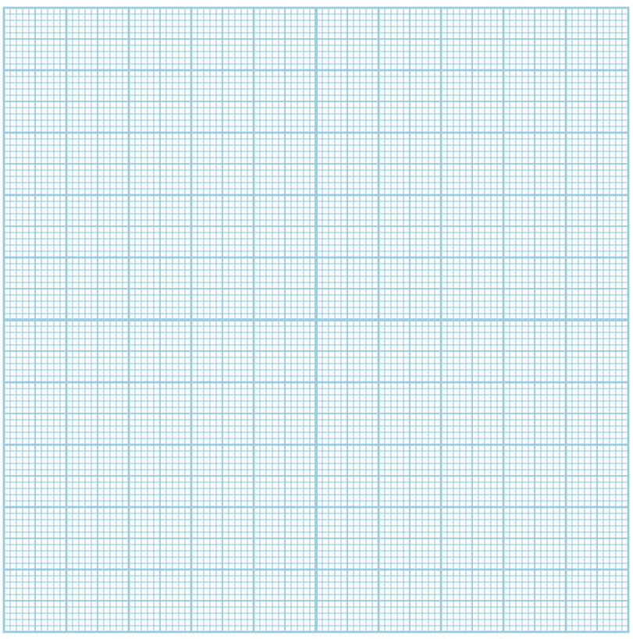
How to complete a biological drawing
1 | Your drawing and its label lines must be done with a really sharp pencil (not a pen).
2 | Your drawing should take up at least half the page / space available.
3 | Lines need to be clear and continuous – not ragged or broken – and no shading or colouring is allowed.
4 | Ensure the proportions are correct, i.e. different areas are the right size relative to each other, and that your drawing is a true likeness of the specimen that you are drawing.
5 | Label all the different areas of tissue that you have shown, writing the words in pencil or pen.
6 | Rule the label lines (in pencil). Don’t let the label lines cross each other and do not write on the label lines.
7 | Make sure the label lines touch the part you are labelling.
8 | Annotations - add concise notes about the structures/features labelled on your drawing.
9 | Include a scale - add a scale bar immediately below the drawing if necessary.
10 | Include a title stating what the specimen is.

TASK: Complete a biological drawing in the space provided to show the plant cells from onion tissue in the light micrograph below:

The magnification of this image is x100. Measure the length of the cell in the image that is labelled. Measure this in mm. Use this measurement and the magnification to calculate the actual length of this cell in mm.
Use the formula below to help you:
Answer:

Standard Form
We use standard form to easily manage very large or very small numbers.
For example, the number 0.00000000000087 may be written as 8.7 × 10⁻¹³
In this form, 8.7 × 10⁻¹³ is the product of two numbers: 8.7 is the digit number, and 10⁻¹³ is the exponential number.

Here are some further examples of numbers in standard form:

Decimal | Standard form
134 000 | 1.34 x 10⁵
0.0034 | 3.4 x 10⁻³
82 000 000 | 8.2 x 10⁷
270 | 2.7 x 10²
0.000 000 000 026 | 2.6 x 10⁻¹¹

TASK: Complete the following questions
Convert the following in to standard form:
- 32000
- 0.0006
- 104000
- 18200000
- 9230000

Convert the following numbers from standard form to decimals:
- 3.26 x 10⁴
- 8.4 x 10⁻³
- 7.27 x 10⁷
- 1.26 x 10²
- 8 x 10⁻⁵

Units and prefixes
One of the reasons we use the international system of units is because it makes the conversion of units (especially those with different prefixes) mathematically simple.
We use prefixes as shorthand for standard form when using commonly occurring very large or very small numbers. This makes it easier to discuss and talk about sets of these numbers.
For example, the length 0.0000000023 m may be written as 2.3 × 10^{–9} m 2.3 is the digit number and is kept. 10^{–9} is known as the exponential number and can be replaced with the prefix ‘n’ pronounced as ‘nano’.
Hence 0.0000000023 m = 2.3 × 10^{–9} m = 2.3 nm

Here are the common unit prefixes you are likely to encounter:

TASK: Convert the following numbers into metres:
- 3 km
- 20 cm
- 2.3 mm
- 4.550 nm
- 5.1 micrometres

Mean, median and mode values
For any range of observed measurements there should be a central or average value. This could simply be the MIDDLE value or MEDIAN or it could be the most common value the MODE.
The arithmetic MEAN is determined by adding together all the observed values and then dividing by the number of measurements taken.
TASK: complete the following calculations.

Find the MEAN values for the following data sets:
1. Volume of gas collected in 60s in cm³. 62,75,65,70,68,67.
2. Number of birds visiting a table per hour. 33,31,38,32,41,24
3. Diameter of seeds mm. 12.5, 14.0, 11.5, 11.0, 9.5.

Find the MEDIAN values in the following data sets:
1. 23, 27,28,24,32,30,31,29,26,26
2. 127,130,199,142,175,150,131
3. 10,6,13,16,8,7,9,12,9,11

Find the MODAL value of the following data sets:
1. 12,14,16,20,21,21,28,30,32,34
2. 0.1,0.9,0.6,0.8,0.2,0.6,0.7
3. 4,6,5,10,7,8,4,4.

Final Task: Create an A4 sized poster to show what is found inside the cell and annotate your drawings with the functions of each organelle as listed on the specification (see link above). You may wish to include colour!

